Lab 7 took me almost 2 weeks to finish, putting my chances of submitting Lab 8 at severe risk. Luckily, I do believe that it works perfectly now, so I will proceed with testing. As usual, we begin with pylint tests.

Pylint Testing:

I actually got a very good score, 8.85/10, on my first test. I got errors about unused imports, trailing newlines, too many return statements, and an unnecessary “elif” statement.

My next score was actually lower than the previous one: 8.11/10. This is because I disturbed the functionality of the code while trying to fix the return statement problems. I had to reverse my fix and test again.

After removing, I received a score of 9.49/10. This would be my highest one, as I didn’t find a way of fixing the return statements without disrupting functionality. It was now time for the test cases.

Test Cases:

|  |  |  |  |  |
| --- | --- | --- | --- | --- |
| Test Case: | Input: | Expected Output: | Actual Output: | Pass? |
|  | Registering  Username: ma  Password: At#4khkkgurw | The first page to appear is Login Page. Upon clicking on “Sign Up” button, user is redirected to the Registration page. Once credentials are entered, and submit button is clicked, user is redirected to Login page. | The first page to appear is Login Page. Upon clicking on “Sign Up” button, user is redirected to the Registration page. Once credentials are entered, and submit button is clicked, user is redirected to Login page. | Yes |
|  | Logging In (Same Credentials) | After user enters credentials, they are taken to the homepage. | After user enters credentials, they are taken to the homepage. | Yes |
|  | Images Properly Displayed | User sees all images after logging in. | User sees all images after logging in. | Yes |
|  | Logging in with short password. | Error message “Password must contain at least 12 characters.” Is displayed. User stays on Login page. | Error message “Password must contain at least 12 characters.” Is displayed. User stays on Login page. | Yes |
|  | Using “Sign Up” redirect button to go from Log In page to Registration Form | User redirected to registration form. | User redirected to registration form. | Yes |

Test Case 1 Screenshots:

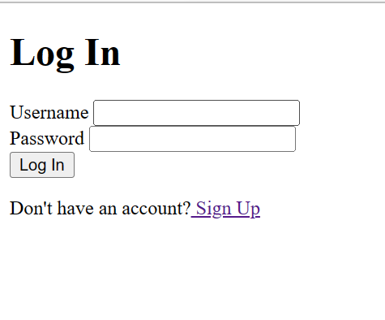

Test Case 2 Screenshots:

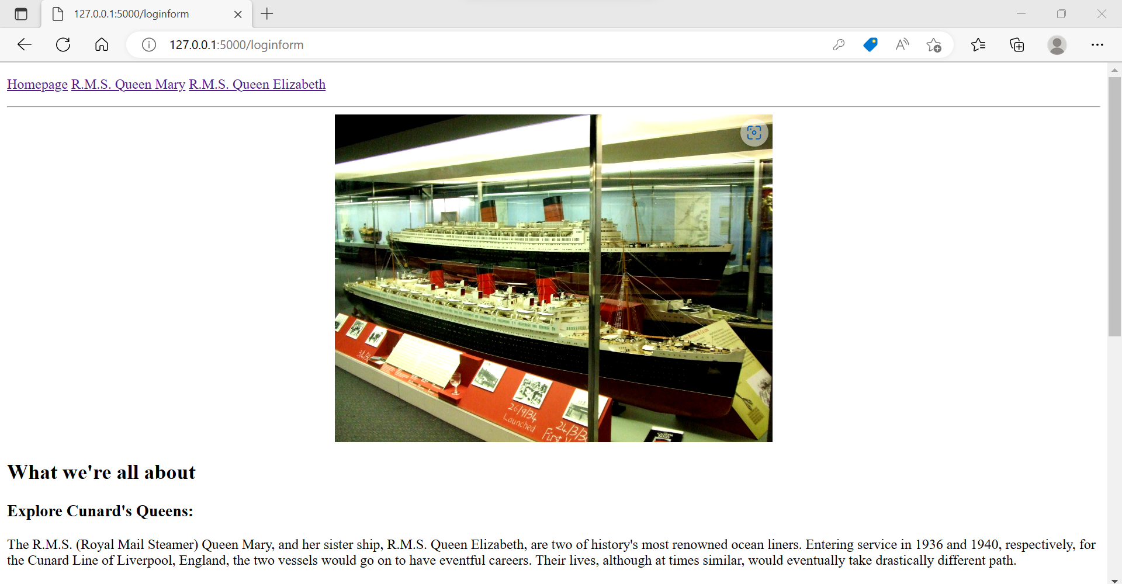

Test Case 3 Screenshots:

Test Case 4 Screenshot:

Test Case 5 Screenshot:

Conclusions:

Even though I submitted this almost a week late, and ran into a lot of trouble, the program worked flawlessly at the end. The most trouble I ran into was when trying to create the registration form. After battling this for a few days, I decided to just make the registration form an almost identical copy of my login form. I also did not rename the assignment to “Lab 7” for fear of disrupting something. The only downside is that my time for finishing Lab 8 (which I have not even started yet) has been reduced to a couple of hours.